Nutrition in surgery
LECTURE No. 2

Artificial Nutritional Support

What are the indications of nutritional support?
- Any patient who has sustained 5 days of inadequate nutritional intake.
- Any patients who is anticipated to have no or inadequate nutritional intake.
The period may be less in patients with pre-existing malnutrition.

Fact:
The indications for nutritional support are the “inadequate intake” rather than specific disease condition e.g. Crohn’s disease, pancreatitis...etc.

Techniques used for nutritional support:
- Enteral feeding
Delivery of nutrition into the GIT.

Fact:
Alimentary tract should be used whenever possible.
- Normal Food.
- Oral Supplements (Sip Feeding)
- Tube feeding Techniques.
- Polymeric feeds require digestion
- Elemental feeds (monomeric) amino acids or peptides, less palatable.
- Newer Feeds fortified with:
- Glutamine &fibers to optimize intestinal nutrition.
- Arginine & fish oil as immunonutrients.

Sips feeding
- Used in patients who can drink but whose impaired appetite.
- Used in patients in whom adequate intake cannot be maintained with ad libitum (freely or as much as the patient wish) intake.

Tube feeding techniques
- Nasogastric tube (Ryle’s) feeding.
- Gastrostomy Feeding.
- Postpyloric Feeding
- Nasojejunal tube feeding.
- Jejunostomy

Nasogastric tube (Ryle’s) feeding
- Tube blockage is common.
- It’s appropriate in a majority of patients but surely with some contraindications.
- Fine-bore feeding tube (internal diameter is < 3mm) causes less gastric and esophageal erosions.

Nasojejunal tube feeding
- Less like to cause aspiration pneumonia.
- More useful in pancreatitis where the edematous pancreas causes a degree of gastric outlet obstruction.
- It often necessitates the use of fluoroscopy or endoscopy to achieve placement.

Gastrostomy
- The placement of a tube through the abdominal wall directly into the stomach.
- If enteral feeding is needed for prolonged periods (4-6 weeks), then gastrostomy tube feeding is preferable to an indwelling nasogastric tube.
- There are two options for gastrostomy:
- Percutaneous endoscopic Gastrostomy (PEG) - two techniques.
- Surgical Gastrostomy - 2 techniques.

Jejunostomy
- Surgical placement of a tube into the jejunum.
- May cause leak and subsequent peritonitis.

Complication of enteral feeding
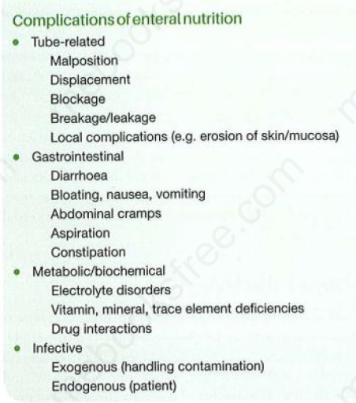
- Parenteral feeding:
Total Parenteral Nutrition (TPN) is defined as the intravenous provision of all nutritional requirements, without the use of the gastrointestinal tract.

Indications of parenteral nutrition
- Massive resection of the small bowel.
- Intestinal fistula.
- Prolonged intestinal failure for other reasons.

Route of delivery

Peripheral:
- This route is usually used when a short period of total parenteral nutrition needed (less than 2 weeks).
- Two types of peripheral Parenteral routes:
- Catheter can be inserted into a peripheral vein and maneuvered into the central venous system; this is called "Peripherally Inserted Central venous Catheter-PICC".
- The mean duration of it is about 7 days.
- When thrombophlebitis occurs, the vein is destroyed.
- Conventional short cannula in the wrist veins.
- Used to infuse the nutritional requirements on a cyclical basis over 12 hours.
- After that the cannula is removed and resited in the contralateral arm.
- It has the advantage that it avoids the complications of central venous administration, but suffers the disadvantage that it is limited by the development of thrombophlebitis.

Central venous line:
Central veins are:
- Subclavian vein (the best for TPN)
- Internal jugular vein.
- External jugular vein.

- Central venous catheter should be tunneled subcutaneously to minimize the risk of infection.
- Hickman line is used for longer-term TPN.
- X ray confirmation for the catheter tip in the distal superior vena cava and exclusion of pneumothorax is essential before starting TPN.

Complications of parenteral nutrition:

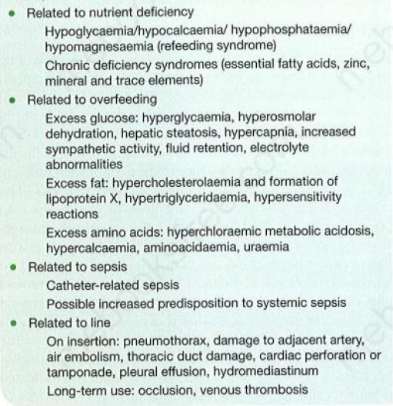

Refeeding Syndrome
- Severe fluid and electrolyte shift in malnourished patients undergoing refeeding.
- Can occur with either enteral or parenteral nutrition, but more common in the latter.
- It results in:
- Hypophosphataemia
- Hypocalcaemia
- Hypomagnesaemia
- These electrolyte disorders can result in:
- Altered cardiac function and arrhythmias
- Deterioration of respiratory function
- Deterioration of liver function
- Seizures, confusion and coma
- Tetany and death

Patients at risk
- Alcohol dependency
- Severe malnutrition
- Anorexics
- Those who have undergone prolonged fasting

Treatment
- Avoid overfeeding.
- Calorie delivery should be increased slowly
- Vitamins administrated regularly.
- Treatment of hypophosphataemia and hypomagnesaemia.

